**1. Metadata :**

The <meta> tags provide essential information about the webpage, which is often used by search engines and web browsers to understand the content and behaviour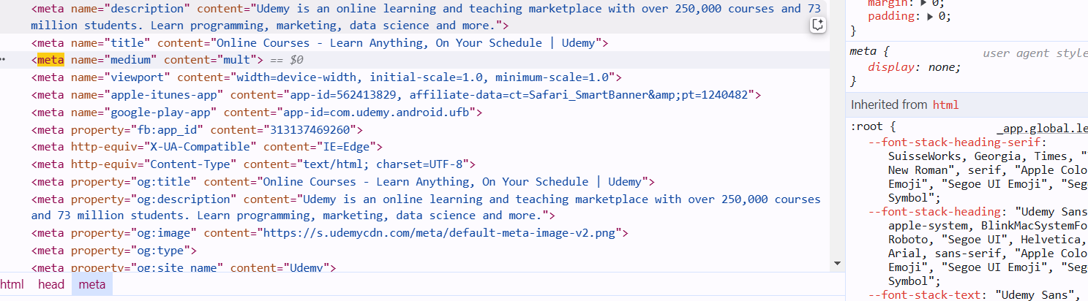of the page.

**2. Headings and Semantic Elements**

Headings (such as <h1>, <h2>, etc.) and other semantic elements like <header>, <footer>, and <section> help define the structure and meaning of the page content.

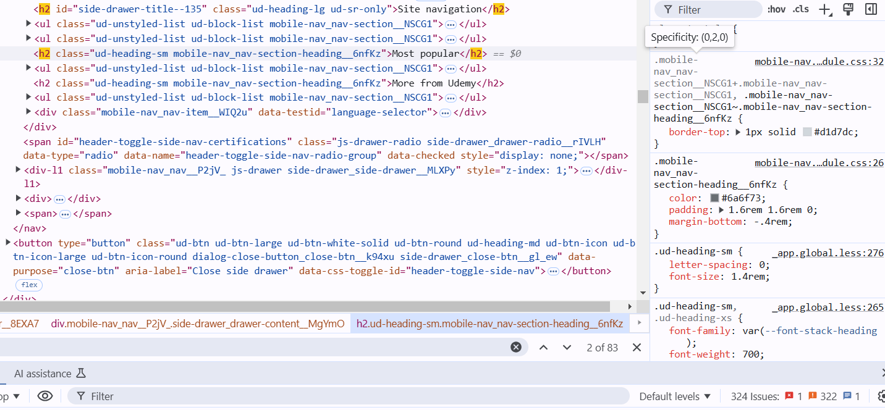

**3. Multimedia Elements**

Multimedia elements are used to embed or reference audio, video, and other media on a web page

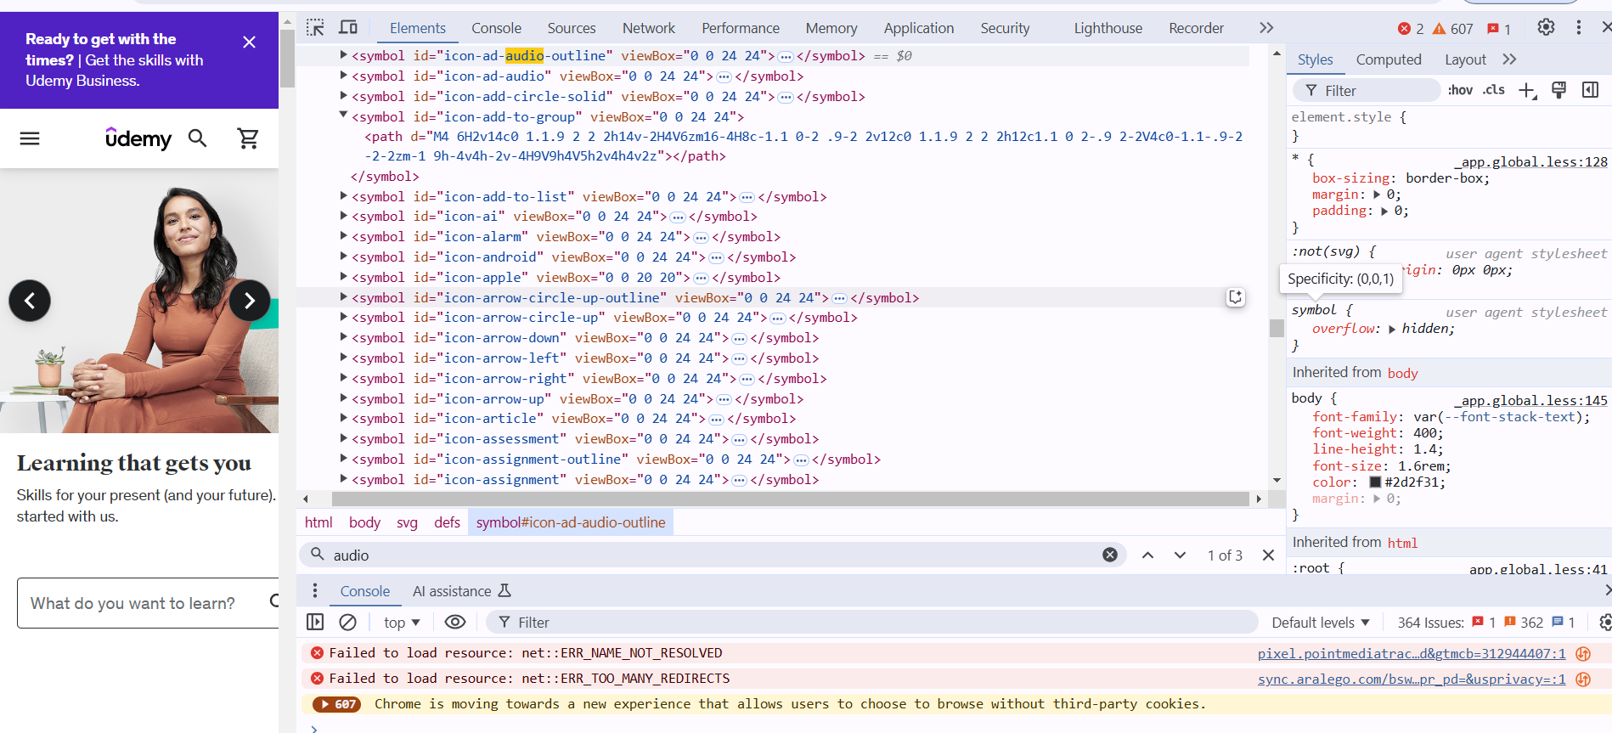

**4. Security-Relevant Tags**

Security-relevant tags help protect the site from various vulnerabilities.

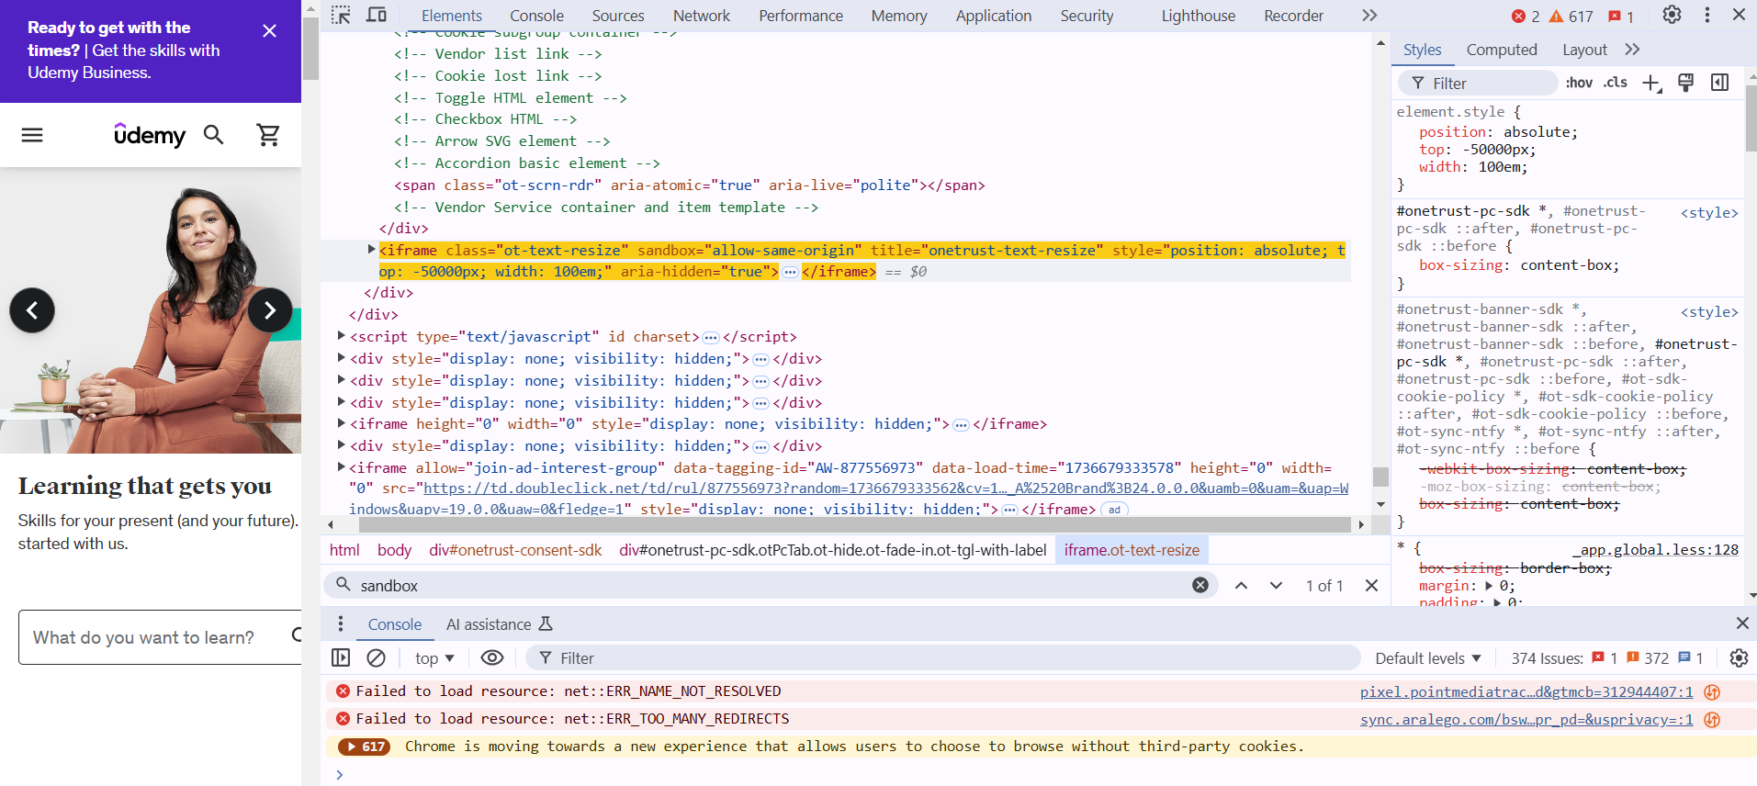

**5. CORS (Cross-Origin Resource Sharing)**

xCORS headers are used to define which domains are allowed to access resources on the server, helping prevent unauthorized access.

**6. SRI (Subresource Integrity)**

SRI is used to ensure that a file (e.g., a script or stylesheet) hasn't been tampered with by verifying its cryptographic hash.

